Q1. ​As we know, the scanner module of a compiler is responsible for isolating the tokens of

an input program and providing them along with various information about them to the parser.

Q11​. (5) What is a token in the context of a programming language?

A token is a string to be replaced with another string during scanning and it defines lexeme types.

Q12.​(5) List the items of information that must accompany a token when the parser

requests a token from the scanner. Explain what each item of information is and its

purpose.

Token – This allows the parser to work it's way through the LL(1) grammar.

Lexeme – This allows the parser to do necessary inserts/lookups on the symbol table.

Row – This allows the parser to print out user-friendly errors(not strictly necessary for compilation)

Col – This allows the parser to print out user-friendly errors(not strictly necessary for compilation)

Q2.​Consider the process of designing and implementing a scanner for a programming

language. We need a list of tokens and their definitions in order to construct a correctly

functioning scanner.

Q21​. (5) The definitions of the tokens are given as regular expressions. What is the

purpose of using regular expressions as opposed to English prose to describe the

tokens?

A regular expression can be translated into a Deterministic Finite Automaton which can be implemented as code to recognize specific strings.

Q22​. (5) How do regular expressions help in the process of designing and

implementing a scanner?

Regular expressions provide an easy blueprint for recognizing different token types and are naturally grouped based on their leading character, this provides much of the direction for implementing a scanner.

Q3. ​Suppose that a new token named currency_literal​is to be added to a programming

language. This token is to stand for all strings that are currency values in dollars.

Valid examples of currency values include:

$1 $1.00 $0 $0.00 $0.05 $75 $75.44

Invalid examples include:

$01 $00 $1.5 $.05 $1.758

In words, a string that matches the currency pattern:

● starts with “$”

● which must be followed by a digit

● if that digit is 0

● else if that digit is not 0

○ the string must end, or

○ the string must be followed by a “.” and exactly two more digits

○ that digit must be followed only by zero or more digits and end when something

other than a digit is encountered, OR

○ that digit must be followed by only by zero or more digits that are in turn

followed by a “.” which in turn is followed by exactly two digits

As you answer the following subparts of Q2 you may assume that you have the following

auxiliary regular expressions to use: digit​:= 0 | 1 | 2 | 3 | 4 | 5 | 6 | 7 | 8 | 9 pos_digit​:= 1 |

2 | 3 | 4 | 5 | 6 | 7 | 8 | 9

Q31. ​(10) Give a regular expression for currency. Use the digit​and or pos_digit

auxiliary expressions as appropriate to shorten the regular expression

currency_literal​. Use the regular expression notation given below.

● concatenation is just two regular expressions listed in sequence with a space

between, for example letter digit,​which stands for the regular expression that

matches a single letter followed by a single digit.

● alternation (OR) is two regular expressions listed in sequence with a | between,

such as letter | digit​, which stands for the regular expression that matches

either a single letter or a single digit.

● "0 or more occurrences" of a particular regular expression is represented by

enclosing that regular expression in curly braces, such letter {letter | digit}​,

which stands for the regular expression that matches strings formed as a single

letter followed by 0 or more letters and digits in any combination.

● parentheses are used to enforce the evaluation order of operations in regular

expressions where necessary, for example letter (letter | digit) {letter | digit}

is a regular expression that matches strings that start with a letter that is

followed by one or more letters and digits in any order. On the other hand, if the

parentheses are omitted to give letter letter | digit {letter | digit}​this is the

regular expression that matches strings that consist of exactly two letters along

with those that start with a digit and have any number of following letters and

digits.

No other notation can be used.

currency_literal (0|(pos_digit(|{digit})))(|.digit digit)

Q32.​(10) Give a deterministic finite state automaton (fsa) that recognizes currency literal

values within the context of a program. Assume as specified in class and for your project that

● the dispatcher of the scanner calls this fsa when a $ is encountered and

● the $ is where the file pointer is pointing when the fsa starts processing the token.

Then:

● Add commentary to your FSA at appropriate points to make it a useful design for

practical scanning (i.e., that will help in implementing the FSA in a program), including

○ actions to take when certain states are reached so that the line and column

numbers are correctly registered, and the lexeme matched is properly

recorded.

○ ensuring that the file pointer is pointing to the first character after the lexeme

that is matched by the FSA

○ noting when if and when a scan error has occurred.

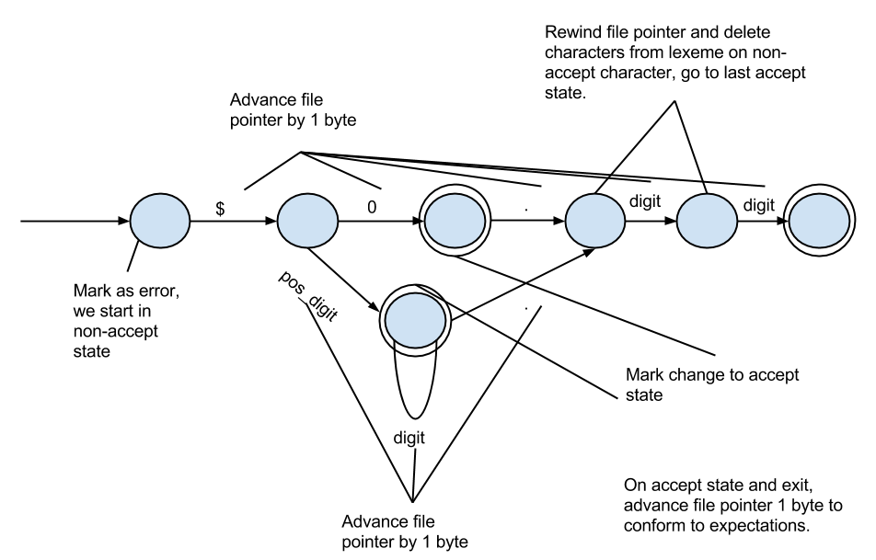

Q4. ​Consider a scanner designed the way described in class.

Q41​. (5) What is its big O time complexity given a program P as input?

Big O notation of the scanner discussed in class should be O(n).

Q42​. (5) Explain what n in your stated time complexity represents.

This time complexity represents that we must only cycle through our code one time per token, with n being the number of tokens.

Q43​. (5) Defend your stated time complexity.

Due to the way in which we have grouped and combined FSA's, each run through our parser will result in a token(MP_ERROR or otherwise) and advance the file pointer at least 1 byte until EOF.

